The City of Takoma Park - Solutions to Open-Source Housing & Development Data

***Tyler Barker, Matt Vice, Bella Noumba,***

***Salina Fessehazion, Bryanna Soh***

[**Figma Linked Here**](https://www.figma.com/file/xC1k2rEfUcdxRlXg1AyyUY/Untitled?type=design&node-id=0%3A1&mode=design&t=uyGGqKwAYOrl2aQq-1)

Meeting Notes for 4/12/2024

DUE FOR THE 19th

* Use ARCGIS for opening the data
* Licensing for ARCGIS
* Check out QGIS or R <https://www.qgis.org/en/site/>
* Market Research Presentation Google Doc (SOP generation)
* Narrative Information
* Data Aggregation
* Propose Dates for Final Presentation Week of the 13th

DUE FOR THE 26th - Visualization

* Wireframes
* Figma Prototype
* Visualization taking data and shapefiles and incorporating third party datasets

# Work Breakdown Structure



# 

# Task List

**Phase One - Groundwork**

1. **Research**
   1. Market Research
   2. Comparative Analysis
   3. Update the Background Research and Context Analysis Document
   4. Create a Page of Research Highlights
2. **Data**
   1. Collecting Sample Data Sets from Client
   2. Get familiarized with the range of data sets our client works with
   3. Data Aggregation: Determine how to condense data, what to include/exclude from larger external databases

**Phase Two - Development**

1. **Prototyping**
   1. Wireframing
      1. Create Wireframes
      2. Get Feedback
      3. Iteration ^
   2. Figma Prototype
      1. Get Feedback
      2. Iteration ^
   3. Final Prototype

**Phase Three - Testing & Rollout**

1. **Start Backend** 
   1. Develop SOPs
      1. Design schema using SQL (Most Likely)
         1. Determine types of data & their relationships
      2. Define Date Methods for…
         1. Ingestion
         2. Updates
         3. Access
         4. Exporting & Visualization
      3. Determine plan for integration with existing site if necessary
      4. Develop database & integrate with UI
      5. External API development
   2. Present final deliverable

# Project Schedule

| **Week** | **1** | | | **2** | | **3** | **4** | | **5** | **6** | | **7** | **8** | **9** | **10** | **End** |
| --- | --- | --- | --- | --- | --- | --- | --- | --- | --- | --- | --- | --- | --- | --- | --- | --- |
| **Starting** | **Mar**  **11** | | | **Mar**  **18** | | **Mar 25** | **Apr 01** | | **Apr08** | **Apr**  **15** | | **Apr 22** | **Apr 29** | **May 06** | **May**  **13** | **May**  **20** |
| **Phase**  **One** | **1.1** | **1.2** | **1.3** |  |  |  |  | |  |  | |  |  |  |  | **P**  **R O J E C T  E N D** |
|  |  | **2.1** | **2.2** | **2.3** |  |  | |  |  | |  |  |  |  |
| **Phase**  **Two** |  |  |  |  |  | **3.1** | **3.2, 3.3** | |  |  |  |  |  |  |  |
| **Phase**  **Three** |  |  | |  |  |  |  | | **4.1.1** | **4.1.2, 4.1.3** | | **4.1.4,4.1.5** | | |  |
|  |  | |  |  |  |  | |  |  |  |  | **4.2** | | |

**Takoma Park Group: Requirements Document**

**Abstract**

The client is the City of Takoma Park. The City of Takoma Park is made up of a collection of city boards, committees, commissions, and council members who work together to execute their plans. Their priorities include: advancing a community of belonging, fiscally sustainable government, environmentally sustainable community, engaged, responsive, service-oriented government, and community development for an improved & equitable quality of life.

Our project purpose is to support the City of Takoma Park’s Housing & Community Development Department (HCD) in its efforts to increase accessibility to publicly available datasets and visualizations with the general public. This project is important because closing the information gap is key to empowering citizens to become as informed as possible. This is particularly important for Takoma Park residents who want to increase their awareness of the city’s housing data to measure racial demographics, where housing violations occur, bus station locations, etc. This project addresses the City of Takoma Park’s transparent racial problems. It’s important to note that this data not being readily accessible makes it seem like it is being hidden intentionally. Our project will increase transparency between the city and residents, fostering trust. This project will improve services and customer satisfaction for the City of Takoma Park.

**Executive Summary**

The project intends to develop a Standard Operating Procedure (SOP) and share data pertaining to Housing and Development. To complete this goal, we will be provided with related datasets and data dictionaries by Ira Kowler. This will also allow us to gain a better understanding of what additional data is needed to better information transparency. Additionally, the group will have to perform market research by finding existing, open-data sites (i.e. Montgomery County, DC, etc.) and looking at factors such as the data they are providing, their user interfaces, and more to use as inspiration for the project. To visualize the data, our team will be using software tools such as Geographic Information Systems (GIS).

**Project Details**

1. **Constraints:** We may encounter technical and cultural constraints. Technical constraints come about when developing an accessible and inclusive user interface design. For example, there is a limit to our understanding of the visual or physical challenges that those of the disabled community encounter while navigating digital spaces. Cultural limitations may come about when considering diversity of language. Additionally, personal biases may influence our decision-making when thinking of what information or datasets to focus on.
2. **Facts and Assumptions:** The City of Takoma Park has data that they would like to open-source, but limited technical experience. We can assume that they will need assistance with researching best practices for open-sourcing data and existing open-source data sites.
3. **Current Situation:** We have met with the City of Takoma Park once. We have a basic understanding of what they are looking for but are looking to further flesh out what is expected of our team.
   1. **Context Diagram** [(Miro Linked Here)](https://miro.com/welcome/SWpjeHJGbG5NdEpLQnpSem9rYkRMMzZJSUtEWUZ2b3A1UTZHejliR0NiR3pXZlJ0b1lRb1pjSnYyODVNcHNmanwzNDU4NzY0NTQ0NTQxNzM2NTYyfDE=?share_link_id=610532197971)

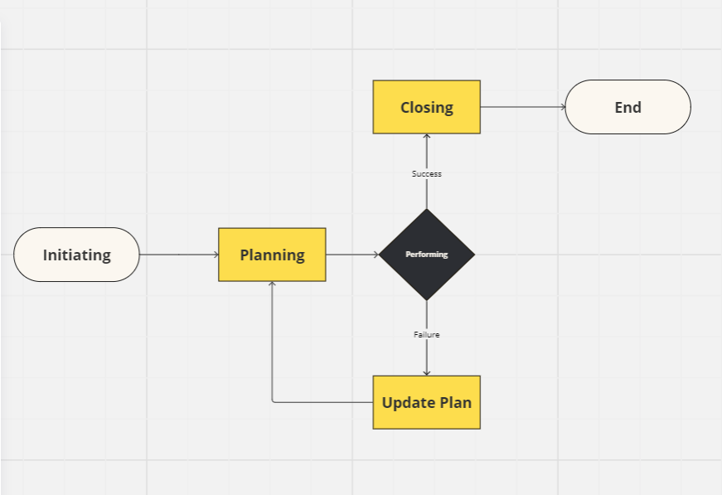

1. **Scope of the Project**
   1. Increasing accessibility to The City of Takoma Park’s datasets for the general public
   2. Improving information transparency
2. **Use Case Diagram**

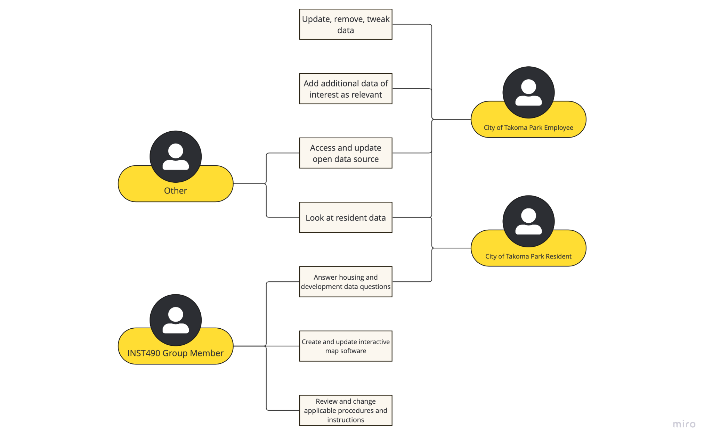

1. **Functional Requirements** (one for each)
   1. **Description**: The database should enable the viewing and pulling data with ease. Users should be able to extract data for querying.
   2. **Specification(s)**: Software: Figma (Prototyping), Google Slides (Presentation), SQL/MySQL (Database Design)
2. **Non-functional Requirements**
   1. **Look and Feel Requirements**
      1. **Appearance**: The dataset should look professional and similar to the example datasets provided.
      2. **Style**: Similar to publicly available datasets and other datasets. A test visualization, mappable functionality, and address search.
   2. **Usability and Humanity Requirements**
   3. **Ease of Use:** Open data source, as accessible as possible, long term including a glossary of terms on what the data actually means.
   4. **Operational and Environmental Requirements**
      1. **Physical Environment:** There is no physical environment, the database will be a prototype online.
      2. **Interfacing with adjacent systems:** Web portal that lives on the Takoma Park website.
3. **Maintainability and Support Requirements**
   1. **Supportability:** Maintenance of the database should be conducted by the staff working in the city of Takoma Park on a semi-regular basis.
   2. **Adaptability:** How will the visualization be scaled? The dataset needs to be somewhat scaled down to make it easier for the user.
4. **Security Requirements** 
   1. **Access:** The database should be accessible, Takoma Park has a very diverse demographic and the final deliverable should be able to accommodate different languages as well as
   2. **Integrity:** The data needs to be correct and up to date. Data can change and therefore it would become unhelpful.
   3. **Privacy:** Data can contain sensitive information. Our Data is accessible to the public, but we need to keep in mind the privacy of Takoma Park citizens.
5. **Open Issues**
   1. **Resolvable in Project Duration:** Creating a database that increases **accessibility** of public data for the city of Takoma Park.
   2. **Future Issues:** Difficulty with **data integration** as the client uses shared data sets, resulting in differences in data formatting as well as having to break down extremely large datasets (i.e. federal data sets like Census Data). Another concern is **data maintenance**, the client is concerned with the staff's “tech-savviness” and ability to upkeep the dataset and troubleshoot issues when necessary.
6. **New Problems**
   1. **User process changes:** The varied data formatting in future datasets can cause the user process to change.
   2. **Interaction with current systems:** Current systems have data spread across multiple sources with different sources.
   3. **Potential user problems:** Some users may not know what they are looking for. Then it would be difficult to find the data they need if they don’t know what to search for.
7. **Migration to the New Product:** A migration needs to take place swiftly and as quickly as possible. Uploading the new product to the original Takoma Park website should happen during off hours, when the site activity is low.
8. **Risks:** Data is ever-changing and would potentially need to be updated. Our team would need to keep track of the data we are given and make sure that it stays correct.
9. **User Documentation & Training**
   1. **User Documentation:** Users will not need to have documentation to access the data, the data is publicly accessible
   2. **Training:** There will not be training required to access the dataset, Takoma Park staff only need to update the data over time and may require training on how to do this.
10. **Future Requirements**
    1. Research on the City of Takoma Park
    2. Market Research – Comparative Analysis
    3. Standard Operating Procedure (SOP)
    4. Website Visualization
    5. Data visualization
    6. Database Organization

# ***Background Research and Context Analysis***

**Mission**

* *Keeping* the customer process easy to navigate and understand.
* *Choosing* an accessible tool for every small business to utilize.
  + A platform with different language usage.
    - Including a Text to speech for those who need it
* *Considering* different types of businesses
* *Providing* a customer relationship management tool for different businesses, and considering diverse solutions

**Objectives**

* Conducting various analyses of existing software to best meet our client’s needs. Our final deliverables will consist of wireframes and a prototype of the system to display functionality, a conclusive report, and a presentation of our project, as well as additional recommendations for CRM.

**Strategies**

* *Working* on publicly available datasets to design a database or website that gives the general public access to Housing and Development Data in an organized manner.
* *Keeping* weekly communication with the client, and working three days a week on every objective.
* *Maintaining* a steady workflow throughout the project.

**Tactics**

* *Creating* an organized workspace shared among all of the group members.
  + Via a shared Google Drive - we have a running master document containing meeting notes, all of our research, as well as copies of all of our assignments. This is in addition to separate file copies for each assignment.
* *Defining* a standard communication procedure throughout the project through email and Google Meet. Google Meet connects to Google Calendars and helps create cohesive schedules for the best weekly communication.

**Project Objective**

Our project objective is to support the City of Takoma Park’s Housing & Community Development Department (HCD) in its efforts to increase accessibility to publicly available datasets and visualizations with the general public. This project is important because closing the information gap is key to empowering citizens to become as informed as possible. This is particularly important for Takoma Park residents who want to increase their awareness of the city’s housing data to measure racial demographics, where housing violations occur, bus station locations, etc. This project addresses the City of Takoma Park’s transparent racial problems. It’s important to note that this data not being readily accessible makes it seem like it is being hidden intentionally. Our project will increase transparency between the city and residents, fostering trust. This project will improve services and customer satisfaction for the City of Takoma Park.

**Project Stakeholders & Impact**

The main project stakeholders that would benefit from the success of this project is the city of Takoma Park Maryland, and their constituents. For the city of Takoma park they greatly value the transparency of their informed decision making process. The completion of this project would give them the opportunity to showcase the data that they are collecting and using to make their decisions concerning the city. The constituents, because of the intention behind this project, would also be benefiting from this project because it will give them the ability to inform the insights behind a decision made by their local government. As of now, because all data used to make decisions is held internally, there is a seemingly large disconnect between the citizens and the government when it comes to a change in the city. Our project is the potential remedy to this disconnect which would help to garner more trust in the local government by the community. Due to the nature of this project there is likely to be no stakeholders who would not benefit from a successful result.

**Constraints & Limitations**

We may encounter technical and cultural constraints. Technical constraints come about when developing an accessible and inclusive user interface design. For example, there is a limit to our understanding of the visual or physical challenges that those of the disabled community encounter while navigating digital spaces. Cultural limitations may come about when considering diversity of language. Additionally, personal biases may influence our decision-making when thinking of what information or datasets to focus on.

**Project Goal**

Our project goal is to be able to develop a Standard Operating Procedure (SOP) and share data pertaining to Housing and Development. In order to complete this goal, we will be provided with related datasets and data dictionaries by Ira Kowler. This will also allow us to gain a better understanding of what additional data is needed to better information transparency. Additionally, the group will have to perform market research by finding existing, open-data sites (i.e. Montgomery County, DC, etc.) and looking at factors such as the data they are providing, their user interfaces, and more to use as inspiration for the project. To visualize the data, our team will be using software tools such as Geographic Information Systems (GIS).

**Project Transition & Closeout**

As stated above, our final deliverable will be a functioning prototype for a Housing and Development Database. We will execute our project closeout in a 4 part process. First, we’ll start with a **project summary** synthesizing our research, project process, and findings. This will be in the form of a slide show presentation and our final project. We’ll then do a **prototype run-through** where we’ll provide the client with documentation of all relevant information and (if necessary) log-in credentials. This initial run-through will be more of a high-level overview covering UI, design, key features, and purpose. Next will be **client training**, which will include a hands-on practice session for our clients and their staff. We'll focus on the more technical aspects - data entry and management, user analytics, security measures and processes, data retrieval, and systems integration. This will end with a Q&A to ensure a smooth turnover. We’ll end with **feedback**, providing the client with an opportunity to share their final thoughts on the final product and our work as well as a support email where they can reach us with any tech questions they may have down the line.

# ***Requirements Interview***

***Group Notes from the Client Interview on 2/16/2024***

* Group Questions in black
* Client Answers in blue

**General**

1. What has been the major concern in the Takoma Park Area in your opinion?

*Creating a standard process with data sources organized in a single dataset so it could be easily uploaded in a data visualization?*

1. Secondary contact? (anyone else to be included)

[Maisahb@takomaparkmd.gov](mailto:Maisahb@takomaparkmd.gov)

[rosalindg@takomaparkmd.gov](mailto:rosalindg@takomaparkmd.gov)

1. How frequently would you like to be in contact?

Weekly Friday Meetings (Potentially Biweekly)

**Big Idea**

1. What are your top 3 goals for the project?

**Market Research** on existing open data sites (ex. data.montgomery county.gov)

1. What deliverables (other than wireframes) do you imagine receiving at the end of this project?

-Standard Operating Procedure

-Market Research

1. What do you hope to achieve in the next year? (Short-Term Goals)

Identifying three datasets for the open data project. Putting together quick data dictionaries, creating a mock up visualization or wireframe with those datasets.

1. What do you hope to achieve in the next 5 years in Takoma Park? (Long-Term Goals)

Create a space where people can easily access publicly available data instead of asking for data requests.

**Client Experience**

1. What are your current biggest concerns about the project?

* Data Privacy was a concern in the previous semester.

**Immediate course of action**

1. What is the immediate course of action our group needs to take?

* Updated Scope of Work

1. How do we stay in contact throughout the busy semester?

* Create a schedule for meetings

**Past Group Strengths and Challenges**

1. What was a strength from the previous semester’s group?

* Market Research (Reaching out to Account Managers)
* Presentation on Market Research

**Interview Notes**

***Meeting 1:***

Priorities

1. expanding publically available datasets that city uses (open data solutions)
2. Using datamontgomery.gov as an example of how they would like their data to be represented
3. Where to start?
4. Understanding how to efficiently Provide data, data dictionaries, and other functionalities
5. Using the location data to give mappings of the data for Takoma Park (possibility)
6. Valuing the data’s accessibility

***Meeting 2:***

Answers of Outstanding Questions

1. What are the most frequently expressed user frustrations when searching for data?
   1. Lack of a singular set site. There are many publicly available layers of data existing in different places. <https://mcatlas.org/viewer/>
2. What do users most frequently want the data for?
   1. People want the data for an address specific standpoint. How it impacts individuals on a resident basis.
3. How will the data be accessed and queried by users?
   1. Interactive map functionality. <https://mcatlas.org/viewer>
   2. address search
4. What security measures do you envision being implemented, if any?
   1. An entirely public dataset (census data, code enforcement citations) not a major concern on security.
5. What are your leading concerns and why- integration, scalability, etc?
   1. Staff capacity, lack of IT experience on staff. A system needs to be easy to update when a new census becomes available.
6. Have you identified any customers you believe will be “top users” of this database?
   1. Primarily residents learning about their property or their neighbors. (Rental license)

# ***Questions for Meeting #2***

**Outstanding Questions:**

1. What are the most frequently expressed user frustrations when searching for data?
2. What do users most frequently want the data for?
3. How will the data be accessed and queried by users?
4. What security measures do you envision being implemented, if any?
5. What are your leading concerns and why- integration, scalability, etc?
6. Have you identified any customers you believe will be “top users” of this database?

**UMD Capstone - Spring 2024**

**Notes from Mr. Kowler**

*2/16/2024 2:00PM*

| UMD Group Members | City of Takoma Park Staff |
| --- | --- |
| * Bella Noumba - [bnoumba@terpmail.umd.edu](mailto:bnoumba@terpmail.umd.edu) * Bryanna Soh - [bsoh@terpmail.umd.edu](mailto:bsoh@terpmail.umd.edu) * Matt Vice - [mvice@terpmail.umd.edu](mailto:mvice@terpmail.umd.edu) * Salina Fessehazion - [fessehazion.s@gmail.com](mailto:fessehazion.s@gmail.com) * Tyler Barker - [tbarker2@gmail.com](mailto:tbarker2@gmail.com) | * Ira Kowler, Director, HCD (Project Lead) - [irak@takomaparkmd.gov](mailto:irak@takomaparkmd.gov) * Rosalind Grigsby, Planning & Development Services Manager - [rosalindg@takomaparkmd.gov](mailto:rosalindg@takomaparkmd.gov) * Ma’isah Bateman, Planning Intern - [maisahb@takomaparkmd.gov](mailto:maisahb@takomaparkmd.gov) |

Relevant Links:

<https://takomaparkmd.gov/government/housing-and-community-development/>

<https://takomaparkmd.gov/government/city-manager/racial-equity/>

[Full list of open data sources in the US](https://data.gov/open-gov/) (link at the bottom of this page)

<https://data.montgomerycountymd.gov/>

<https://opendata.dc.gov/>

<https://data.baltimorecity.gov/>

[Article on new Seattle Open Data Strategy](https://harrell.seattle.gov/2023/12/15/mayor-harrell-announces-comprehensive-one-seattle-data-strategy-to-advance-best-practices-and-tackle-complex-challenges/)

**Goal Statement**: The City of Takoma Park’s Housing & Community Development Department (HCD) is trying to figure out how to better share publicly-available City datasets and visualizations with the public. As part of that goal, we have a number of questions:

1. What best practices exist among other municipalities in creating open data source websites? What works well or not well from a user perspective in those sites?
2. How should the Department be organizing our existing datasets so they can be more easily shared publicly?
3. What “low-hanging fruit” data visualizations can be created that demonstrate the value of open data for City leadership and elected officials? For example, is there a visualization that can tie to the City’s racial equity goals or tells a story about one of the Department’s ongoing priorities/projects?

City of Takoma Park Next Steps:

* Send out notes from meeting
* Send Weblinks for Relevant Sites
* Development of 2-3 datasets

UMD Team Next Steps:

1. Send out weekly meeting invitation
2. Draft up a scope of work based on the kickoff conversation
3. Do some research on the City

# ***Adjusted Project scope***

| **iConsultancy Statement of Work** | |
| --- | --- |
| **Project Title:** | Takoma Park - CRM Needs Assessment and Market Evaluation 2024 |
| **Start & End Dates:** | January - May 2024 |
| **Project Needs Assessment** | * Goal Statement: The City of Takoma Park’s Housing & Community Development Department (HCD) is trying to figure out how to better share publicly-available City datasets and visualizations with the public. As part of that goal, we have a number of questions: * What best practices exist among other municipalities in creating open data source websites? What works well or not well from a user perspective in those sites? * How should the Department be organizing our existing datasets so they can be more easily shared publicly? * What “low-hanging fruit” data visualizations can be created that demonstrate the value of open data for City leadership and elected officials? For example, is there a visualization that can tie to the City’s racial equity goals or tells a story about one of the Department’s ongoing priorities/projects? |
| **Project Scope:** | * Increasing accessibility to The City of Takoma Park’s datasets for the general public * Improving information transparency |
| **Project Deliverables:** | * Market Research – Comparative Analysis * Standard Operating Procedure (SOP) * Website Visualization * Data visualization * Database Organization |
| **Client-provided Resources:** | * City of Takoma Park Staff Contact Information * Relevant Links * Post-Interview Next Steps |

# 

# 

# ***Deliverables List***

1. Market research on open data source website creation and the user’s experience on those sites
2. Dataset organization for increased accessibility
3. Data visualizations that demonstrate the value of open data for City leadership and officials

# ***Client Meetings***

Initial Interview → 2/16/2024 – 2:00 PM EST

Recurring Interviews → Fridays –2:00 PM EST